**Formula used in solving numerical problems on volumetric analysis:**

    (1) Strength of solution = Amount of substance in g litre-1

    (2) Strength of solution = Amount of substance in g moles litre-1

    (3) Strength of solution = Normality × Eq. wt. of the solute

                                     =  molarity × Mol. wt. of solute

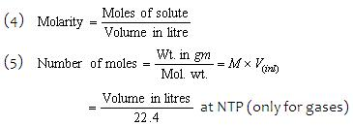

(6) Number of millimoles = Wt. in gm × 1000/mol.wt.   
                                = Molarity × Volume in Ml.   
(7) Number of equivalents   
       =  Wt. in (gm/Eq. wt.) = x × No. of mole × Normality × Volume in litre 

(8) Number of milliequivalents (meq.)   
      = (Wt. in gm × 1000/Eq.wt.) = normality × Volume in ml. 

(9) Normality = x× No. of millimoles   
                         = x× Molarity = (Strength in gm litre-1/Eq.wt.)   
  where x = (Mol. Wt./Eq.wt.), x = valency or change in oxi. Number. 

(10) Normality formula, N1V1= N2V2  
  
     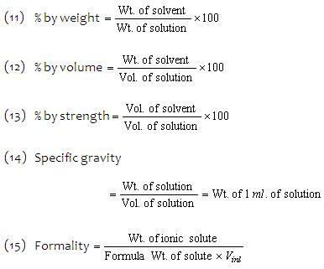  

(16) Mol. Wt. = V.D × 2 (For gases only)